Metal-Era, LLC March 2023
1600 Airport Road
Waukesha, Wisconsin 53188
Phone 800-558-2162
Website www.metalera.com
Email info@metalera.com

Guide Specification
Specifier Notes: This guide specification is written in Construction Specifications Institute (CSI) 3-Part Format in accordance with The CSI Construction Specifications Practice Guide, MasterFormat, SectionFormat, and PageFormat.
This Section must be carefully reviewed and edited by the Architect to meet the requirements of the Project and local building code. Coordinate this Section with Conditions of the Contract, Division 01, other specification sections, and the Drawings. Delete all Specifier Notes after editing this Section.
Section numbers and titles are based on MasterFormat 2020 Edition.

06 10 73

ROOF WOOD NAILER ALTERNTIVE
Specifier Notes: This Section covers all Metal-Era Wood Nailer Alternative products. Consult Metal-Era for assistance in editing this Section as required for the Project.
Optional information is identified in blue font below. Select appropriate options and delete other information as needed. [delete this paragraph]
  - GENERAL
    - SECTION INCLUDES
      - Furnish and install premanufactured roof wood nailer alternative per the drawings and specifications, including all fasteners, and joining. Components and accessories shall be factory-fabricated and supplied by a specified Manufacturer.
      - Contractor shall utilize Manufacturer's technical representative to perform field measuring, takeoff, shop drawing development and order processing for all components specified in this section.
      - If specifying an edge metal product with wood nailer alternative refer to manufacturer’s fascia, coping, or gutter specification guide for more information.
      - If specifying edge metal on separate specification, delete section 2.3.

    - RELATED REQUIREMENTS
Specifier Notes: Edit the following list of related sections as required for the Project. Limit the list to sections with specific information that the reader might expect to find in this Section, but is specified elsewhere.
      - Section 07 71 19 – Manufactured Gravel Stops and Fascia.
    - REFERENCE STANDARDS
Specifier Notes: List reference standards used elsewhere in this Section, complete with designations and titles. Delete reference standards from the following list not used in the edited Section.
      - FM Global (www.fmglobal.com).
      - SPRI (Single Ply Roofing Industry) (www.spri.org):
        - ANSI/SPRI/FM 4435/ES-1 – Wind Design Standard for Edge Systems Used with Low Slope Roofing Systems.
    - PREINSTALLATION MEETINGS
Specifier Notes: Edit the Preinstallation Meetings article as required for the Project. Delete article if not required.
      - Convene preinstallation meeting [1 week] [2 weeks] before start of installation of materials.
      - Require attendance of parties directly affecting Work of this Section, including Contractor, Architect, installer, and manufacturer’s representative.
      - Review the Following:
        - Materials.
        - Installation.
        - Protection.
        - Coordination with other Work
    - SUBMITTALS
Specifier Notes: Edit the Submittals article as required for the Project. Delete submittals not required.
      - Comply with Division 01.
      - Products shall be manufactured in specified manufacturer’s facilities. Products fabricated by installer or other fabricator will not be acceptable unless fabricator can demonstrate to Architect’s satisfaction that products have been tested for resistance in accordance with Test Method RE-1 and RE-2 (Eliminailer-T) or RE-3 (EdgeBox RI) of ANSI/SPRI ES-1.
      - Product Data: Submit manufacturer’s product data, including installation instructions.
      - Shop Drawings: Submit manufacturer’s shop drawings, indicating dimensions, materials, and fasteners.
      - Samples: Submit manufacturer’s sample of roof wood nailer alternative.
        - Sample Length: Minimum 5-1/2”.
      - Manufacturer’s Certification: Submit manufacturer’s certification that materials comply with specified requirements and are suitable for intended application.
      - Warranty Documentation: Submit manufacturer’s standard warranty.
    - QUALITY ASSURANCE
      - Manufacturer’s Qualifications: Manufacturer regularly engaged in the manufacturing of Wood Nailer Alternatives that specified for a minimum of 5 years.
      - Installer's Qualifications:
        - Installer regularly engaged in installation of edge metal products for a minimum of 5 years.
        - Use persons trained for installation of nailers and edge metal products.
    - DELIVERY, STORAGE, AND HANDLING
      - Delivery Requirements: Deliver materials to site in manufacturer’s original, unopened containers and packaging, with labels clearly identifying product name and manufacturer.
      - Storage and Handling Requirements:
        - Store and handle materials in accordance with manufacturer’s instructions.
        - Keep materials in manufacturer’s original, unopened containers and packaging until installation.
        - Store materials in clean, dry area indoors.
        - Do not store materials directly on floor or ground.
        - Protect materials and finish during storage, handling, and installation to prevent damage.
    - WARRANTY
      - Wind Warranty Period: Warranted in wind conditions up to 215 mph with a Lifetime wind warranty. Warranty specified for individual products below.
      - Warranty Period, Product: 5-year workmanship warranty covering replacement or repair of products that are defective in material or workmanship.
  - PRODUCTS
    - MANUFACTURERS
      - Manufacturer: Metal-Era, LLC, 1600 Airport Road, Waukesha, Wisconsin 53188. Phone 800-558-2162. www.metalera.com. info@metalera.com.
Specifier Notes: Specify if substitutions will be permitted.
      - Substitutions: [Not permitted] [Comply with Division 01].
    - ROOF WOOD NAILER ALTERNATIVE
Specifier Notes: Use the following to specify "Eliminailer T" roof wood nailer alternative.
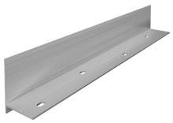
Metal-Era Website: 1.5” 3” 5.2”

      - Roof Wood Nailer Alternative: “Eliminailer-T”
        - Description:
          - For use with metal decks, masonry wall or on an existing wood nailer.
        - Approvals:
          - ANSI/SPRI/FM 4435/ES-1 to 1200 psf Horizontal.
          - FM Approved up to 1-990 Perimeter and Corner.
          - Miami-Dade County Approval.
          - Florida Product Approval.
        - Extruded Material: Aluminum
Extruded Thickness: Varies based on size of product.
        - Extruded Lengths: 12’-0”.
Specifier Notes: Specify 1-1/2” height when using rigid polyiso roof insulation 1-1/2” to 2” thick. Specify 3” height when using rigid polyiso roof insulation 3” to 3-1/2” thick. Specify 5.2” height when using rigid polyiso roof insulation 5.2” to 5.7” thick.
        - Height: [1-1/2”] [3”] [5.2”].
Specifier Notes: Specify horizontal roof flange dimension. Specify 2.5” or 4” when being used on existing wood nailer substrate. Specify 5.5” when being used on metal or masonry substrate.
Isolation barrier required at locations of dissimilar materials, such as masonry or treated wood.
        - Horizontal Roof Flange onto Substrate:
          - For 1-1/2” height and 3” height: [2-1/2”] [5-1/2”].
          - For 5.2” height: [4”] [5-1/2”].
        - Fastener Holes: Pre-Punched, Slotted holes, staggered at 6” over 2 rows.
        - Isolation Barrier Requirement: [YES] [NO].
Specifier Notes: Use the following to specify "Eliminailer T" for metal roof retrofits roof wood nailer alternative.

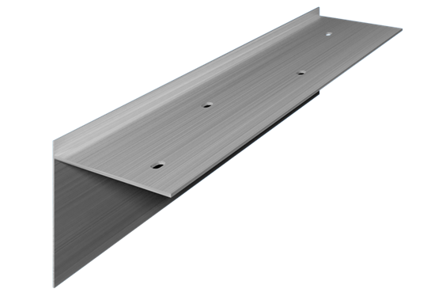
Metal-Era Website

      - Roof Wood Nailer Alternative: “Eliminailer-T"
        - Description:
          - For use with metal roof retrofit projects with flute-fill insulation.
        - Approvals:
          - ANSI/SPRI/FM 4435/ES-1 to 1200 psf Horizontal.
          - FM Approved up to 1-990 Perimeter and Corner.
          - Miami-Dade County Approval.
          - Florida Product Approval.
        - Extruded Material: Aluminum
Extruded Thickness: Varies based on size of product.
        - Extruded Lengths: 12’-0”.
Specifier Notes: Specify 1-1/2” height when using rigid polyiso roof insulation 1-1/2” to 2” thick. Specify 3” height when using rigid polyiso roof insulation 3” to 3-1/2” thick.
        - Height: [1-1/2”] [3”].
        - Flange: 5-1/2”
Specifier Notes: Specify horizontal roof flange dimension.
        - Fastener Holes: Pre-Punched, Slotted holes, staggered at 6” over 2 rows.
Specifier Notes: Specify roof pitch (4:12 MAX).
        - Roof Pitch: [_______:12]

Specifier Notes: Use the following to specify "EdgeBox RI" roof wood nailer alternative.
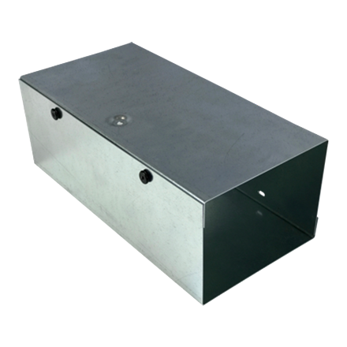
Metal-Era Website

Specify specific height and width.
Height: Min. 1.25” Max. 16” (Tested Max. 4.5”)
Width: Min. 3.5” Max. 16” (Tested Max. 5.5”)

      - Roof Wood Nailer Alternative: “EdgeBox RI”
        - Description:
          - For use with metal decks, masonry wall or on an existing wood nailer.
        - Approvals:
          - ANSI/SPRI/FM 4435/ES-1 to 526 psf Horizontal and 911 psf Vertical.
          - FM Approval up to 1-540 Perimeter and 1-360 Corner.
          - Miami-Dade County Approval.
          - Florida Product Approval.
Specifier Notes: Specify box height and width.
        - Height: [____”]
        - Width: [____”]
Specifier Notes: Specify material. Delete spine material if not required.
Spines Required over 6” Height or Width (installed 24” O.C.) Specify 20 ga. galvanized steel if height and/or width is >6” but <=12”. Specify 16 ga. galvanized steel if height and/or width is >12” but <=16”.
        - Box Material:20 ga. galvanized steel (2-pieces)
        - Spine Material: [20 ga. galvanized steel] [16 ga. galvanized steel] [Not required]
        - Fastener Holes: Pre-Punched
        - Lengths: 12’-0”.
        - Accessories:
          - Material same as product
- End Cap
  - Left
  - Right
- Fasteners: Appropriate for intended substrate.
  - EXECUTION
    - EXAMINATION
      - Examine areas to receive materials.
      - Verify surfaces to support materials are clean, dry, straight, secure, and of proper dimensions.
      - Notify Architect of conditions that would adversely affect installation.
      - Do not begin installation until unacceptable conditions are corrected.
    - INSTALLATION
      - Install materials in accordance with manufacturer’s instructions at locations indicated on the Drawings.
      - Install materials to provide watertight termination at leading edge of roofing material.
      - Install materials in accordance with manufacturer’s instructions to allow for thermal movement.
      - Install isolation barrier under roof flange at locations of dissimilar materials, such as masonry or treated wood.
    - PROTECTION
      - Protect installed materials to ensure that, except for normal weathering, materials will be without damage or deterioration at time of Substantial Completion.

END OF SECTION

